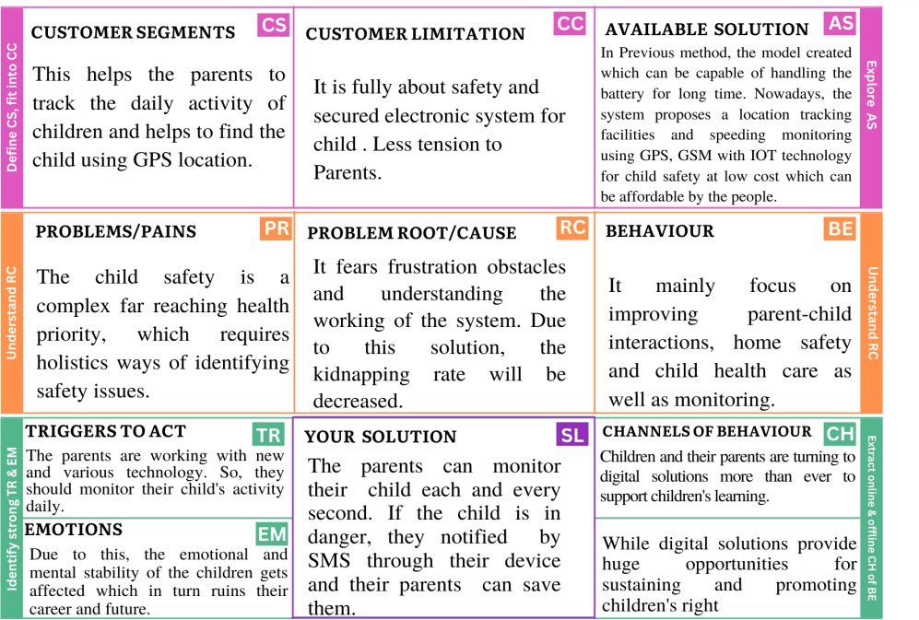**Project Title:** IOT based safety Gadget for child safety Monitoring and Notification **Project Design Phase-I-**Solution Fit **Team ID:** PNT2022TMID12665

D